RainFall Event Filter:-

The application is used to point out the maximum rainfall intensity intervals (5 min) of the area under analysis then try to project the full rain event of the same.
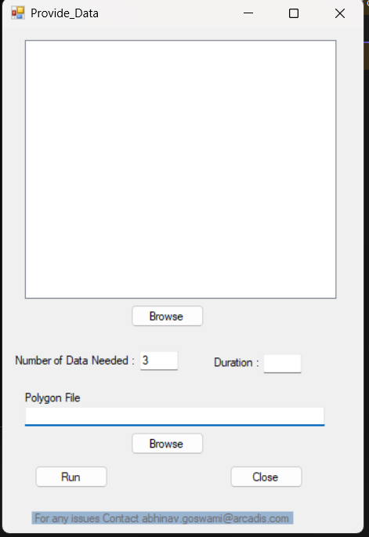
List of all the raster files (tif) selected by user
Duration of event needed in hours
Browse the area shapefile
Run the process
Close the Event
Area shapefile
Give the number of top(max) rainfall data needed to be filtered out at top
Browse the rainfall data tif files (Band 1 should be rainfall)

Once all files are selected and data is provided after clicking on Run button a window to show progress will come with statements for filtering the event.
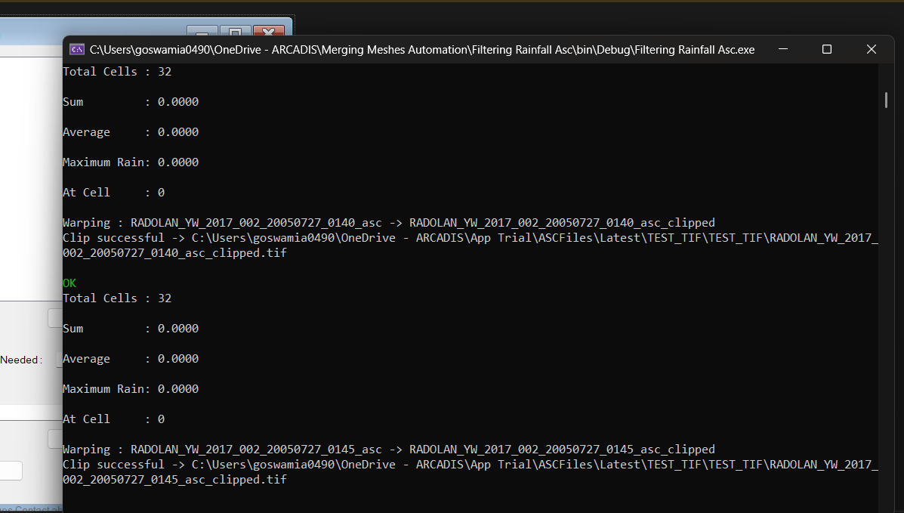
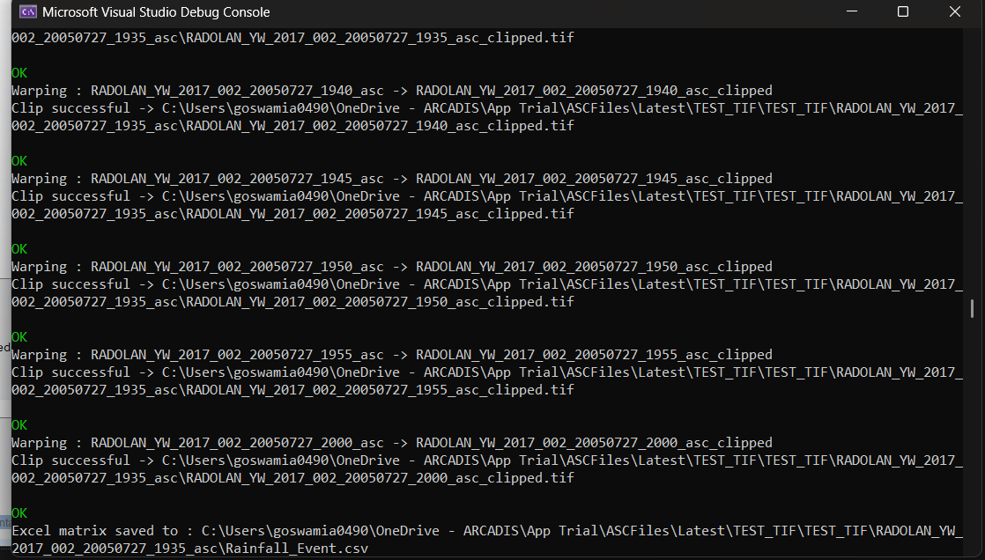

After process is completed app will close automatically and a folder will be formed with the result rasters of the event and an excel file with the output data for each cell of the event in the same folder, in the following Form :-
